TGFβ1, Active Human, recombinant
Catalog: SC-038-1 1ug
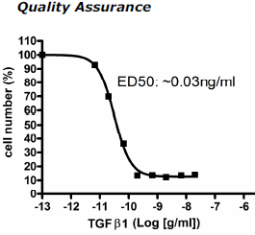
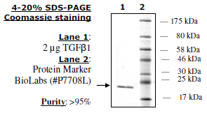
SC-038-2 5ug
Description: Human TGFb1 (GenBank
Accession #NM_000660), a.a. 279-390(end),
disulfide-linked homodimer. MW= ~25 kDa.
Source: FreeStyle 293-F cells.
Endotoxin Level: <1 EU/μg.
Biological Activity: measured by TGFβ1’s
ability to inhibit mIL-4-dependent
proliferation of HT-2 mouse helper T cells.
The ED50 is <0.05ng/ml.
Application: Useful for cell culture and
for the study of signaling and apoptotic
pathways.
Formulation: Lyophilized from a 0.2 μM
filtered, aqueous solution
Reconstitution: Supplied as a lyophilized
solid. Reconstitute in sterile 0.2 M acetic acid
with 0.1% BSA.
Stability: ≥12 months at –80°C (as a solid).
Store reconstituted protein in aliquots at –20°C to
–80°C for up to 6 months. Avoid freeze/thaw
cycles.
References:
1. Derynck, R. et al. (1985). Nature
316(6030):701-5.
2. Bourdrel L., et al. (1993). Protein Expr.
Purif. 4:130-140.
3. Munger, J.S., et al. (1997). Kidney Int.
51:1376-1382.
Disclaimer:
Some applications in which this product can be used may be covered by patents issued and applicable in certain countries. Because purchase of this product does not include a license to perform any patented application, users of this product may be required to obtain a patent license depending upon the particular application and country in which the product is used.

Limited Product Warranty:
This warranty limits BioPioneer’s liability to replacement of the product. No other warranties of any kind, express or implied, including, without limitation, implied warranties of merchantability or fitness for a particular purpose, are provided by BioPioneer. BioPioneer shall have no liability for any direct, indirect, consequential, or incidental damages arising out of the use, the results of use, or the inability to use this product.

