Pre-made inducible lentivirus, fluorescent controls:
for validation of tetracycline inducbile expression system

SC-030-I RFP inducible control lentivirus 200ul, ~1 x 10⁷ IFU/mL

Storage: <-70 °C, avoid repeat freeze/thaw cycles. Stable for 6 months at <-70oC.

- Product Description:

Lentivectors are HIV-1 (Human Immunodeficiency Virus 1) derived plasmids. They generate replication-incompetent lentivirus that can be transduced into almost all types of mammalian cells, including primary and non-dividing cells. Lentiviral particles (LP) are lentivirus supernatant generated from lentivectors express a specific gene or RNAi construction.

Lentivirus is the easiest and most effective method for delivering genes into the majority of mammalian cell types, including non-dividing and primary cells. It allows genes to be integrated into the host cell genome for long-term expression.

BioPioneer provides pre-made optional inducible expression lentiviruses for fluorescent proteins or specific human or mouse genes with various selection markers. To validate the inducible system in your cell lines, BioPioneer provides inducible lentivirus controls which have been generated from BioPioneer’s optional inducible lentiviral system.

The inducible controls contain GFP or RFP under control of the optional inducible promoter, enabling convenient verification of tetracycline-inducible effects by simple monitoring of the GFP or RFP signal under a fluorescence microscope. The controls also contain a fluorescent-antibiotic fusion dual slection marker under a RSV promoter which is not affected by induction. The dual marker provides a convenient way to monitor viral transduction efficiency and select positive cells by either antibiotic killing or fluorescence sorting (See vector scheme above).

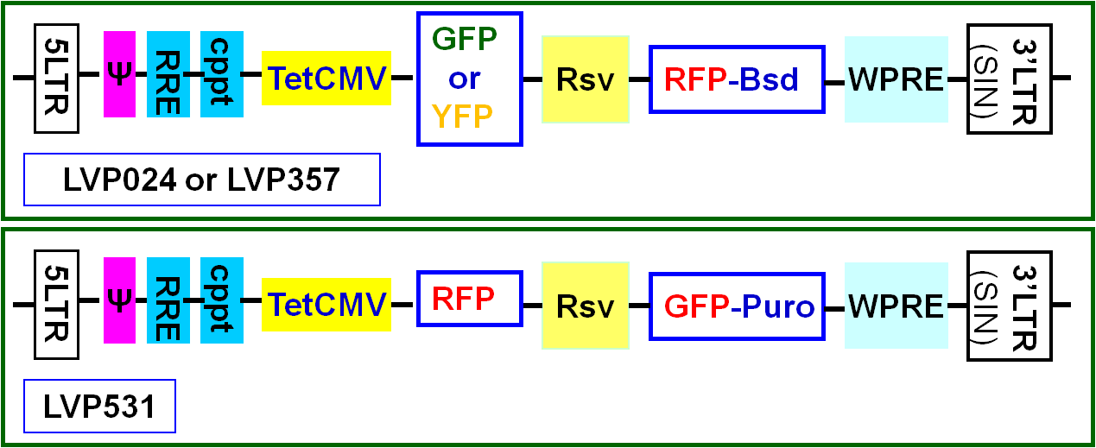

The VSV-G pseudotyped lentiviral particles are generated in 293T cells, and are provided in two formats:

- DMEM containing 10% FBS
- PBS without any additives (suitable for serum sensitive culture or for the hard-to-transduce cells, or for in vivo applications.

- About optional tetracycline inducible expression:

The inducible lentivirus controls can be used for regular constitutive high expression without the requirement for tetracycline induction, or they can also be used for tetracycline inducible expression. The inducible suCMV promoter (TetCMV) has two copies of the tetracycline operator sequence. Expression becomes inducible only when the tetracycline regulator protein (TetR) is present in advance; in this case, TetR stops transcription, which can be activated by the addition of tetracycline. Inducible expression is tetracycline dose dependent; generally, 1-2 µg/ml of tetracycline is used. The image below illustrates how inducible expression works.

If inducible expression is desired, the repressor regulator protein (TetR) must be expressed in advance or at the same time as transduction. The presence of tetR can be achieved by the following methods:

- TetR stable cell lines that constitutively express the TetR protein
- Co-transfection with a TetR expression plasmid and a target-inducible expression vector
- Co-transduction with TetR lentiviral particles and inducible gene expression lentiviral particles

Co-transduction with BioPioneer’s premade TetR lentiviral particles is the best method for delivering the TetR protein.

- Key features:

- High GFP, YFP, and RFP inducible expression levels and high viral titer
- Convenient monitoring of transduction efficiency by the constitutively expressed RFP or GFP signal.
- Dual markers: transduced cells can be sorted by fluorescent signal or selected for antibiotic resistance.

- Safety Precaution:
BioPioneer lentiviral particles adapts must advanced lentiviral safety features (using the third generation vectors with self-inactivation SIN-3UTR), and the premade lentivirus is replication incompetent. However, please use extra caution when using lentiviral particles. Use the lentiviral particles in Bio-safety II cabinet. Ware glove all the time at handling Lentiviral particles! Please refer CDC and NIH’s guidelines for more details regarding to safety issues.
- References:
- OGorman et al., 1991; Sauer, 1994).
- Molecular Therapy (2003) 7, 460–466;
- Annu Rev Microbiol. 1994;48:345-69.
- Microbiol Mol Biol Rev. 2005 Jun;69(2):326-56.
- NIH Guidelines for Biosafety Considerations for Research with Lentiviral Vectors. (Link).
- CDC guidelines for Lab Biosafety levels (Link).
Warranty:
This product is warranted to meet its quality as described when used accordance with its instructions. BioPioneer disclaims any implied warranty of this product for particular application. In no event shall BioPioneer be liable for any incidental or consequential damages in connection with the products. BioPioneert’s sole remedy for breach of this warranty should be, at BioPioneert’s option, to replace the products.

