Pre-made Lentiviral Particles for RFP

Catalog # SC-030
RFP(Bsd) lentiviral particles, 1x10⁷ IFU/ml, 200ul

Storage: < -70 °C, avoid repeat freeze/thaw cycles. Stable for > 6 months.

Product Description:
Lentiviral system is a gene delivery tool using lentivectors for gene expression or knockdown. Lentivectors are HIV-1 (Human Immunodeficiency Virus 1) derived plasmids, used to generate lentiviral particles (lentivirus) that can be transduced into virtually all kinds of mammalian cell types or organs, including stem cells, primary cells and non-dividing cells both in vivo and in cell culture system. Particles stably integrate into the transduced cells’ genome for long term expression. Therefore, lentivirus holds unique promise as gene transfer agents.

Pre-made lentiviral particles expressing YFP proteins are generated from BioPioneer Inc.’s high expression lentiviral system. YFP gene was first cloned into lentivectors with different selection antibiotic markers (See vector scheme below for each catalog product). Each fluorescent was codon optimized to generate brighter fluorescent signal. Then, expression lentivectors were co-transfected with BioPioneer’s proprietary packaging mix into a 293T cell . The pre-made lentiviral particles are VSV-G pseudotyped viruses.

BioPioneer’s premade lentiviral particles are best in the class, demonstrating the brightest fluorescent signal, strong transduction efficiency. Each particles was validated in lot by lot basis and its quality is guaranteed.

Particles were provided in two formats:
- Regular particles in DMEM medium with 10% FBS and 60ug/ml polybrene;
- Particles that concentrated and buffer exchanged into PBS as in vivo ready status.

Schematic representation of lentivector for fluorescent protein
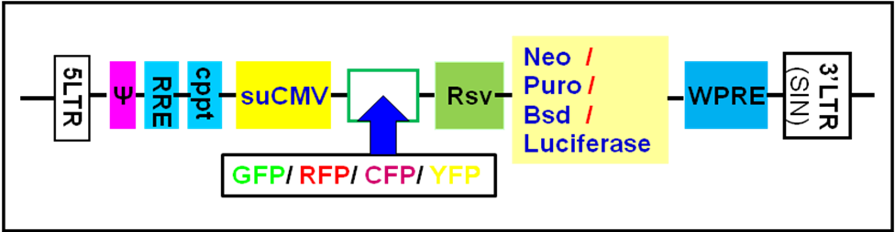

Cat#: SC-030:

Transduction Protocols:

- Adhesive cells Transduction Protocols:

Note: A quick application protocol is: add 50ul virus into one well in 24-well-plate where cell density is at 50% ~ 75%. At 72 hours after virus added (no need to change medium), pass cell into antibiotic containing medium, or sort the cells via fluorescent signal.

Day 0: Seed the desired cells in complete medium at appropriate density incubate overnight. (Note: at the time of transduction, it grows to 10% ~50% confluent.)
For example, seed Hela cells at 0.5 x 10⁵/ml x 0.5ml in a well of a 24-well plate;

Day 1: Remove the culture medium from the cells. Add fresh, warmed, complete medium (0.5ml). Thaw the Pre-made lentiviral stock at room temperature. Add appropriate amount of virus stock to obtain the desired MOI. Return cells to 37°C/CO2 incubator.

Day 3: At the time of ~72hr after transduction, Check the transduction rate via fluorescence image with a suitable filter under fluorescent Microscope, or calculate the exact transduction % rate via Flow Cytometry System (FACS) or any flow cytometry (such as Quava machine).

Day 3 + (optional): Transduced cell can be sorted out via FACS. Or you can select transduced stable cell line by its specific antibiotics (dependent upon the antibiotic types). A pilot experiment should be done to determine the antibiotic’s kill curve for your specific cell line. (Refer to any literatures about How to generate stable cell lines.)

- Suspension cells transduction Protocols:

- Grow your cell in your completed suspension culture medium, shaking in flask in CO2 incubator;
- Measure cell density. When cell grow to ~3 x 10⁶ cell/ml, measure cell viability (should > 90%), then diluted cells into 1 x 10⁶ cell/ml in completed medium;
- Transduction: thaw lentiviral particles at room temperature. Simply add premade lentiviral particle into the diluted cells at ratio of: 200ul virus per 2ml cells (Note: depend upon the cell types; you may need to use more or less viruses). Grow cells in flask, shaking in CO2 incubator.
- At 24 hour after transduction, add equal amount of fresh medium containing related antibiotics (Note: each particles contain an antibiotic marker and the antibiotic amounts to use is depend upon cell types). Grow cell shaking in CO2 incubator.
- At 72 hours after transduction, check fluorescence under microscope or calculate the transduction efficiency using cell sorting machine (like FACS or Guava machine).
- You can sort the fluorescent positive cells or keep selection the antibiotic resistant cell to generate a stable cell lines.

Transduction Example :

Figure 2: RFP Expression in A549 cells. A549 cells were transduced with 50ul Pre-made RFP lentivirus in 24-well plate. RFP signal was visualized at 72 hours after transduction. Images were taken under microscope, the left image under RFP filter, the right image under bright light.

Safety Precaution:
BioPioneer’s lentiviral particles adapts must advanced lentiviral safety features (using the third generation vectors with self-inactivation SIN-3UTR), and the premade lentivirus is replication incompetent. However, please use extra caution when using lentiviral particles. Use the lentiviral particles in Bio-safety II cabinet. Ware glove all the time at handling Lentiviral particles! Please refer CDC and NIH’s guidelines for more details regarding to safety issues.

References:
- J Virol. 2000 November; 74(22): 10778–10784.
- Hum Gene Ther (2003) 14: 1089-105.
- Mol Ther (2002) 6: 162-8.
- NIH Guidelines for Biosafety Considerations for Research with Lentiviral Vectors. (Link).

Warranty:
This product is for research use only. It is warranted to meet its quality as described when used accordance with its instructions. BioPioneer disclaims any implied warranty of this product for particular application. In no event shall BioPioneer be liable for any incidental or consequential damages in connection with the products. BioPioneer sole remedy for breach of this warranty should be, at BioPioneer’s option, to replace the products.

