AccuRuler RGB Protein Ladder (New)
Extended Broad Range With Additional 3.5KD Fragment
Catalog #: PM-001, 100 loading

Description:
The new Prestained Protein Ladder is a three-color protein standard with 13 pre-stained proteins covering a wide range molecular weights from 3.5 to 245 kDa. Proteins are covalently coupled with a blue chromophore except for two reference bands (one green and one red band at 25 kDa and 75 kDa respectively) when separated on SDS-PAGE (Tris-glycine buffer). The new Prestained Protein Ladder is designed for monitoring protein separation during SDS-polyacrylamide gel electrophoresis, verification of Western transfer efficiency on membranes (PVDF, nylon, or nitrocellulose) and for approximating the size of proteins. The ladder is supplied in gel loading buffer and is ready to use. Do not heat, dilute, add reducing agent before loading.
Contents
Approximately 0.1~0.4 mg/ml of each protein in the buffer (20 mM Tris-phosphate, pH 7.5 at 25°C), 2 % SDS, 0.2 mM Dithiothreitol, 3.6 M Urea, and 15 % (v/v) Glycerol).

Features:
• Sharp and stable
• Two reference bands – red at ~75 kDa and green at ~25 kDa.
• Ready to use – no need to boil.
• 3 μl or 5 μl per loading for clear visualization during electrophoresis on 15-well or 10-well mini-gel, respectively
• 2 μl to 3 μl per well for general Western transferring
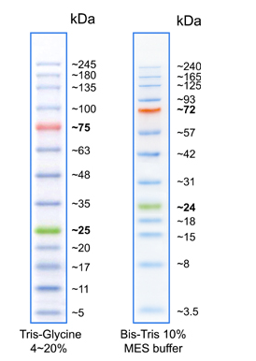
【Protocol】
- Thaw the product and leave it for about 10 minutes at room temperature, mix completely prior to use.
- For mini gels, take 2.5ul μl of this product by micropipette or micro-syringe (wipe off liquid adhered to the outer surface of the tip) and apply it carefully into a well of the gel preferably next to the sample. For large size gel (16 x 20 cm), use 5-10 μl of the product.
- Apply electric current to start electrophoresis.
【Storage】 -20 ℃
【Expiration】 1 year from the date of receiving.

Warranty
These products are warranted to perform as described in their labeling and in BioPioneer literature when used in accordance with their instructions. THERE ARE NO WARRANTIES THAT EXTEND BEYOND THIS EXPRESSED WARRANTY AND BIOPIONEER DISCLAIMS ANY IMPLIED WARRANTY OF MERCHANTABILITY OR WARRANTY OF FITNESS FOR PARTICULAR PURPOSE. BioPioneer’s sole obligation and purchaser’s exclusive remedy for breach of this warranty shall be, at the option of BioPioneer Inc., to repair or replace the products. In no event shall BioPioneer Inc. be liable for any proximate, incidental or consequential damages in connection with the products.

