Noggin Human, recombinant
Catalog #: SC-042
Size: 10 µg
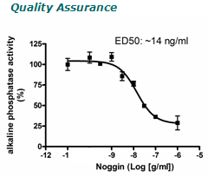
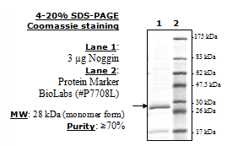
Description: Human Noggin, also known
as symphalangism 1 (SYM1) or synostoses
(multiple) syndrome 1 (SYNS1), GenBank
Accession No. NM_005450, amino-acids 28-
232(end), disulfide-linked homodimer.
MW=~28kDa (monomer), expressed in Freestyle 293F cells.
Endotoxin Level: <1 EU/μg.
Biological Activity: measured by
Noggin’s ability to inhibit BMP-4-induced
alkaline phosphatase production by C2C12
mouse myoblast cells. The ED50 is < 20
ng/ml in the presence of 30 ng/ml of human
BMP-4.
Application:
Useful for the study of enzyme kinetics,
screening inhibitors, selectivity
profiling and cell culture.

Formulation: Lyophilized from a 0.2 μM
filtered, aqueous solution.
Reconstitution: Supplied as a lyophilized solid.
Reconstitute in sterile water with 0.1% BSA to a
final concentration of 0.1 mg/ml. Final formulation
will be 50 mM Tris, pH 8.0, 1.2 M NaCl, 2.7 mM
KCl, 0.1% BSA.
Stability: ≥12 months at –80°C (as a solid).
Store reconstituted protein in aliquots at –20°C to
–80°C for up to 6 months. Avoid freeze/thaw
cycles.
References:
1. Tao, Y.X., et al. (2010). Indian J. Exp. Biol.
48(5):444-52.
2. Mfopou, J.K., et al. (2010). Gastroenter-ology.
138(7):2233- 2245.
3. Chaturvedi, G., et al. (2009). Cell Prolif.
42(4):425-33
Limited Product Warranty:
This warranty limits BioPioneer’s liability to replacement of the product. No other warranties of any kind, express or implied, including, without limitation, implied warranties of merchantability or fitness for a particular purpose, are provided by BioPioneer. BioPioneer shall have no liability for any direct, indirect, consequential, or incidental damages arising out of the use, the results of use, or the inability to use this product.

