1kb plus DNA Ladder (Ready-to-Use)
Catalog Number: MDL-1000P, 100 loadings
Description
An unique combination of a number of proprietary plasmids digested with appropriate restriction enzymes and PCR products to yield 19 fragments, suitable for use as molecular weight standards for agarose gel electrophoresis. The DNA includes fragments ranging from 100-10,000 base pairs. The 500, 1.5K and 3K bands have increased intensity to serve as reference points. The approximate mass of DNA in each band is provided (0.86 μg a load) for approximating the mass of DNA in comparably intense samples of similar size.
Source
PCR products and double-stranded DNA digested with appropriate restriction enzymes, are phenol extracted and equilibrated to 10 mM Tris-HCl (pH 8.0) and 10mM EDTA.
Range: 100-10K bp
Number of bands: 19
Concentration: 172 μg/ml
Package: 86ug / 500ul
Recommended Load: 5 μl / well
Containing orange G, xylene cyanol FF and bromophenol blue as tracking dyes
Storage
Store at 25°C for 6 months
Store at 4°C for 12months
Store at -20°C for 24 months

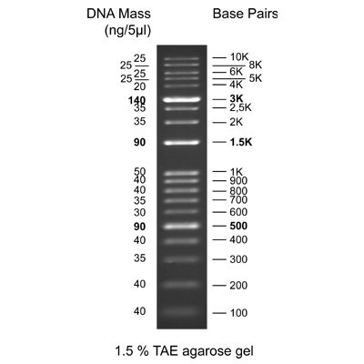

For Research Use Only!

