Item No.: MAQA-1 PreciGeneTM Quick Extraction Kit, 100 reactions

Storage: Keep at 4⁰C

Kit Content:
- Solution A, 10ml
- Solution B, 10ml
- MAT-3.1 Hotstart supermix with loading dye, 100 reactions

Procedure

- Cut 0.2 cm tail snip from mice( or small section of tissue)

- Place the tail snip into 100ul solution A and incubate at 95⁰C for 30-60 minutes.

- Chill sample to room temperature and then vortex to mix the sample.

- Add 100ul of solution B, vortex to mix ((Tail might not be completed digested. It is OK to go to next step)

- Use 1-2ul of above mixture to run PCR reaction immediately or store the mixture at-20ºC

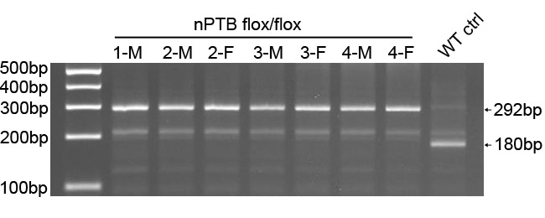
Genotyping result of nPTB mouse with Quick Extraction Kit

For Research Use Only.

