CellMAXTM WST-1 Cell Proliferation Assay Kit

Premixed WST-1 Cell Proliferation Reagent
CP-005 500 reactions
CP-006 1000 reactions

Storage: -20ºC, protected from light

Introduction
Cell proliferation and viability measurements are important tools for research in the life sciences. BioPioneer Cell Proliferation Assay Kit is used for fast and sensitive quantification of cell proliferation and viability. The Premixed WST-1 Cell Proliferation Reagent provides a method to measure cell proliferation based on the enzymatic cleavage of the tetrazolium salt WST-1 to a water-soluble formazan dye which can be detected by absorbance at 420-480 nm ( Fig 1). The simple, one-solution assay saves time and is easy to use in a 96-well plate format.

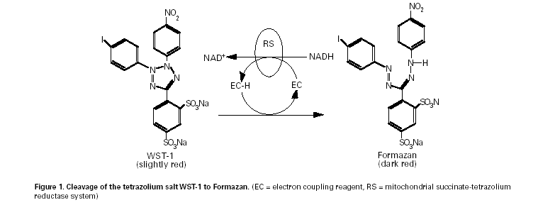

Applications:
Premixed WST-1 Cell Proliferation Assay application include: Measuring cell proliferation in response to growth factors, cytokines, mitogens, or nutrients. Analyzing cytotoxic and cytostatic compounds such as anticancer drugs and other pharmaceuticals. The Premixed WST-1 Cell Proliferation Reagent provides several advantages over other cell proliferation assay reagents:
Accuracy: Absorbance strongly correlates to the number of viable cells.
Ease of Use: The Premixed WST-1 Cell Proliferation Reagent is supplied as a ready-to-use, sterile solution.
The entire assay can be performed in one 96-well plate, without washing, harvesting, or solubilization steps.

Kit Component:
Premixed WST-1 Cell Proliferation Reagent is a clear, slightly red, ready-to-use solution containing WST-1 and an electron coupling reagent, diluted in sterile phosphate buffered saline. If precipitates or turbidity are observed upon thawing, warm the solution to 37°C for 2–10 minutes and agitate to dissolve the precipitates. Once the Premixed WST-1 Cell Proliferation Reagent has been thawed, store at 4°C, protected from light, for up to several weeks. Please note that the solution may become viscous.

Assay Protocol:
1. Culture cells 0.1-5x10⁴/well in a 96-well microplate in a final volume of100 µL/well culture medium in the absence or presence of various amounts of factors tested. Note: For toxicity assays, use more cells to start with (e.g. 5x104 - 5x105 cells/well).
2. Incubate cells for 24-96 hours.
3. Add 10 µL/well premixed WST-1 solution to each well. Note: If the cells are cultured in a different volume of culture medium, increase or decrease the amount of WST-1 solution accordingly.
4. Incubate the cells for 0.5 to 4 hours in standard culture conditions. Note: The appropriate incubation time depends on the individual cell type and cell concentration used. Therefore it is recommended that you determine the optimal incubation time for each experimental setup used.
5. Shake thoroughly for one minute on a shaker.
6. Measure the absorbance of the treated and untreated samples using a microplate reader at 420-480 nm depending on the filters available. The reference wave length should be more than 600 nm. Note: Using the same amount of culture medium and WST-1solution solution in an empty well as a blank position for the microplate reader.

This product is for research only, not for diagnostics and clinical use.

