BP-FectinTM Mammalian Cell Transfection Reagent
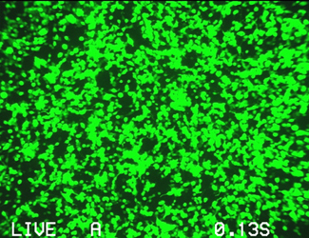
Catalog: BP-Fectin-1, 1.5ml
BP-Fectin-2, 2x1.5ml

293 cell line transfected with BP-FectinTM

Description BP-FectinTM mammalian cell transfection reagent is a proprietary formulation of cationic polymers optimized for high transfection efficiency, low cytotoxicity, and ease of use. BP-FectinTM transfection reagent is a superior alternative to a number of other transfection techniques including calcium phosphate coprecipitation, electroporation, microinjection, biolistic particle delivery, and complex formation with DEAE-dextran. BP-FectinTM transfection reagent offers excellent performance in both stable and transient transfection of both mammalian and insect cells. 1.5 ml of BP-FectinTM transfection reagent provides enough reagent to perform up to 400 transfections in standard 35-mm dishes. BP-FectinTM transfection reagent is supplied as a ready-to-use sterile solution and is Ideal for high-throughput transfection in a multi-well plate format.

Advantages • High transfection efficiency for both adherent and suspension cells.
• High transfection efficiency for both stable and transient transfections.
• High transfection efficiency in both serum-containing and serum-free media.
• Simple and easy to use with highly reproducibility.
• No need to remove media after transfection.
• Minimal cytotoxicity.

Storage Condition
Store at 4 °C. If stored properly, the product is stable for 12 months or longer.

General considerations
• Cells should be sub-cultured regularly to avoid over confluent growth. Use only healthy and rapidly growing cells for transfection. Conditions for cell growth and density should be consistent for optimal reproducibility.
• Use only highly purified endotoxin-free DNA for transfection.
• Serum will enhance transfection efficiency. However, serum must not be present at the time of DNA/ BP-FectinTM complex formation.
• Antibiotics can be present at the time of DNA/ BP-FectinTM complex formation.
• The ratio of plasmid DNA to BP-FectinTM should be kept at 1 ug of plasmid DNA per 8 ul of BP-FectinTM as a starting point.

Transfection protocol
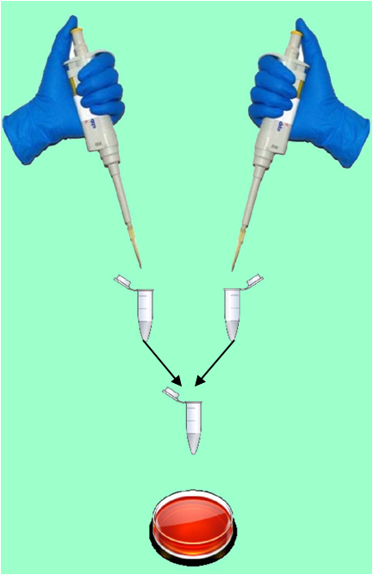

The following protocol is given as an example for the transfection of 293T cell cultured in 6-well plate or 35-mmm dish format with a mammalian cell expression vector pCMV-beta Gal.

1. Seed 1 x 10⁶ healthily growing 293T cells in 1.5 ml of complete culture media (e.g. DMEM with 4.00 mM L-Glutamine, with 4500 mg/L Glucose, without Sodium Pyruvate, with penicillin/streptomycin antibiotics, and 5-10 % fetal or calf serum) one day before transfection. The optimal seeding density depends on cell type and should be adjust accordingly so that the cells are at ~50-75% confluence at the time of transfection.

2. Incubate cells under their normal culture condition (usually at 37°C with 5-10 % CO2).

3. On the day of transfection, transfer 1 ug of plasmid DNA into a 1.5-ml sterile microfuge tube and 8ul BP-FectinTM into another 1.5-ml sterile microfuge tube.

For different cell types, the optimal ratio of BP Fectin™ :DNA(V/V) is around 8:1. We recommend the BP Fectin™ (V):DNA (V) ratio of 8:1 as a starting point which usually gives satisfactory transfection efficiency with invisible cytotoxicity.

4. Add 100ul of serum free media into both tubes. Transfer the solution containing the plasmid DNA into the tube containing BP-FectinTM and mix by pipetting up and down three times.

Note: optimal MEM, PBS buffer or 150mM NaCl can also be used in the DNA and transfection reagent dilution.

5. Incubate the DNA/ BP-FectinTM mixture at room temperature for 15 minutes.

6. Add the DNA/ BP-FectinTM mixture directly into the well containing cells. Mix by gently rocking the plate a few times.

7. Return the plate into the CO2 incubator.

8. Change media if necessary for fast-growing cell types 24 hours after transfection.

9. Harvest cells for beta Gal activity assay.
Table 1. Recommended cell seeding densities and media volumes for transfection.
Culture format | Adherent cell to seed *  (day before transfection) | Suspension cell to seed*  (day on transfection) | Volume of complete$ culture media (ul)
96-well plate | 1.2 x 104 – 3.8 x 104 | 1.2 x 104 – 3.8 x 104 | 100
48-well plate | 2.5 x 104 – 7.5 x 104 | 2.5 x 104 – 7.5 x 104 | 200
24-well plate | 5.0 x 104 – 1.5 x 105 | 5.0 x 104 – 1.5 x 105 | 400
12-well plate | 1.0 x 105 – 3.0 x 105 | 1.0 x 105 – 3.0 x 105 | 800
6-well plate | 2.0 x 105 – 6.0 x 105 | 2.0 x 105 – 6.0 x 105 | 1.5
60-mm dish | 6.0 x 105 – 1.8 x 106 | 6.0 x 105 – 1.8 x 106 | 3,000
100-mm dish | 1.8 x 106 – 5.4 x 106 | 1.8 x 106 – 5.4 x 106 | 7,000

The actual number of cells to be seeded depends on cell type and should be adjusted accordingly. Volumes given are for each well for multi-well plates.
Table 2. Scaling up or down transfections with Sinofection. Note: the actual conditions should be optimized by experiments.
Table 2. Starting point for the optimization of transfection.
Culture format | DNA (ug) | Serum-free media (ul) | BP-Fectin (ul) | Incubation time (min)
96-well plate | 0.05-0.2 | 25 | 0.4-1.6 | 10 – 20
48-well plate | 0.1-0.4 | 35 | 0.8-3.2 | 10 – 20
24-well plate | 0.2-0.8 | 50 | 1.6-6.4 | 10 – 20
12-well plate | 0.4-1.6 | 75 | 3.2-12.8 | 10 – 20
6-well plate | 0.8-3.2 | 100 | 6.4-25.6 | 10 – 20
35-mm dish | 0.8-3.2 | 100 | 6.4-25.6 | 10 – 20
60-mm dish | 1.6-6.4 | 250 | 12.8-51.2 | 10 – 20

Note: The ratio of DNA to BP-FectinTM should be kept at 1 ug plasmid DNA per 4-8 ul of BP-FectinTM when performing titration. The amounts of serum-free media can be kept constant with various amounts of plasmid DNA/ BP-FectinTM.

Trouble Shooting
Lower Transfection Efficiency
1. Use optimal amount of plasmid
2. Use high quality plasmid (OD260/280 >1.8)
3. Ensure the density and morphology of the cells are optimal.
4. Optimize the Polymer/DNA ratio (w/w from 4:1-8:1).
5. Set positive control, such as GFP or a luciferase gene.
Warranty
These products are warranted to perform as described in their labeling and in BioPioneer literature when used in accordance with their instructions. THERE ARE NO WARRANTIES THAT EXTEND BEYOND THIS EXPRESSED WARRANTY AND BIOPIONEER DISCLAIMS ANY IMPLIED WARRANTY OF MERCHANTABILITY OR WARRANTY OF FITNESS FOR PARTICULAR PURPOSE. BioPioneer’s sole obligation and purchaser’s exclusive remedy for breach of this warranty shall be, at the option of BioPioneer Inc., to repair or replace the products. In no event shall BioPioneer Inc. be liable for any proximate, incidental or consequential damages in connection with the products.

For research use only, not for clinic or diagnostic application.

