
Basic Fibroblast Growth Factor (bFGF), Human, Recombinant

Cat. No.: HRP-0011

Size: 50 µg

Description: This recombinant human basic FGF (bFGF) is supplied as a lyophilized powder. It is suitable for use in receptor binding, transmembrane signaling and other cell biology research applications.

Storage: -20°C up to 1 year

Handling: Reconstitute in 1 x PBS to a concentration of 0.1-1.0 mg/mL. Reconstituted bFGF should be stored in working aliquots at -20°C for up to three months or at 4°C for up to 1 week. Multiple freeze/thaw cycles will result in significant loss of activity.

Background: Basic FGF (heparin binding growth factor-2, basic brain-derived growth factor) is a 17-kDa member of the family of heparin binding growth factors, which also includes acidic FGF (HBGF-1) as well as the oncoproteins Int-2 (HBGF-3), HST/K53 (HBGF-4) and HBGF-5. Basic FGF has been found in or associated with a variety of solid tissues, tumors and cultured cells. In vivo, bFGF has been shown to be a potent angiogenic agent (9,16). Recent in vitro studies show that bFGF can bind to heparin-like molecules in the extracellular matrix (ECM) of endothelial cells Xu, et al. demonstrated that bFGF synergizes with the BMP antagonist noggin to sustain undifferentiated proliferation of human embryonic stem (hES) cells under feeder-free conditions.

QUALITY CONTROL

Purity: SDS-PAGE: >95% purity
Endotoxin: <0.1 ng/µg

bFGF
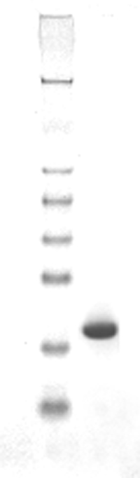
os 17.4 kD

Acitivity: Fully biologically active when compared to standards. The ED₅₀ is ≤ 0.33 ng/mL. ED₅₀ is defined as the effective concentration of bFGF at which the activity is 50% of the maximum response in a cell based assay , which was determined by the dose-dependent stimulation of thymidine uptake by NIH3T3 cells expressing FGF receptors.

³H
0
20000
40000
60000
80000
0.01
0.1
1
10
100
bFGF concentration (ng/ml)
ED₅₀= 0.15 ng/ml
bFGF Activity Test

